Architecture Document
(The student team can select one of the following architectures for their project and they should provide a detailed explanation: Microservices, Event-Driven Architecture, Serverless, or Monolithic architectures. Additionally, they should create relevant diagrams, such as use case, class, DFD, component, sequence, and deployment diagrams, to support their project.)
- Application
  - Microservices
The project follows a Microservices Architecture, where the system is decomposed into independent services to ensure scalability, reliability, and maintainability. Core services include Survey Ingestion for schema-based validation and quarantining, Data Quality services for computing completeness, duplicates, and outliers, and Analytics services for statistical and sentiment-based career confidence analysis, all exposed through secured APIs with caching, pagination, and rate limiting. Supporting services such as authentication, schema registry, alerting, and observability operate independently and communicate via REST and asynchronous messaging, enabling fault isolation and parallel development. This architecture supports Agile development, handles evolving survey data reliably, and allows future expansion without impacting existing components.
- Database
  - ER Diagram

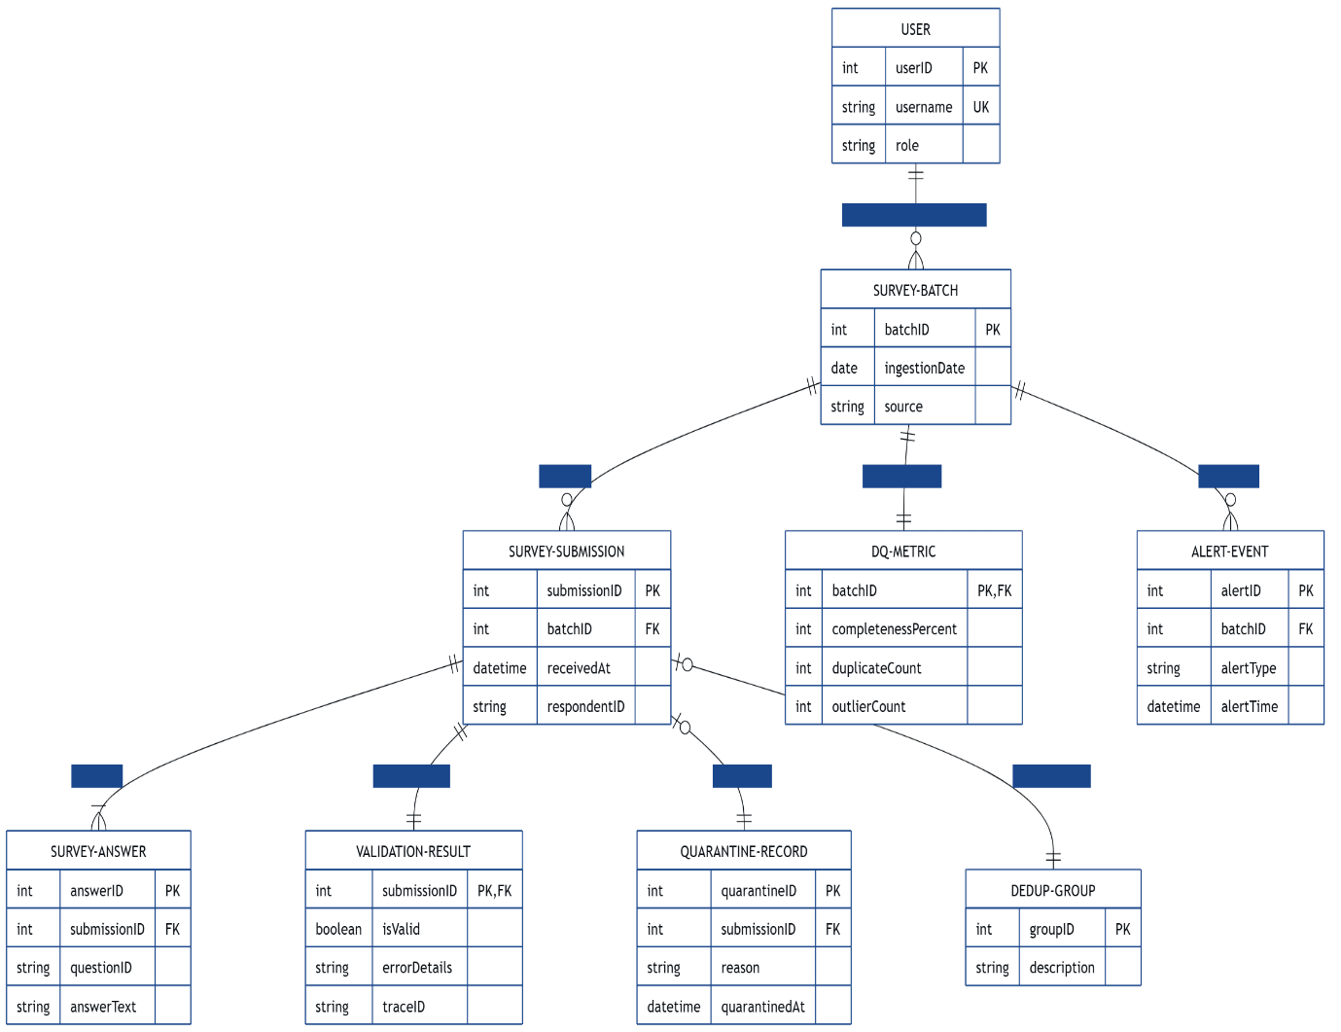
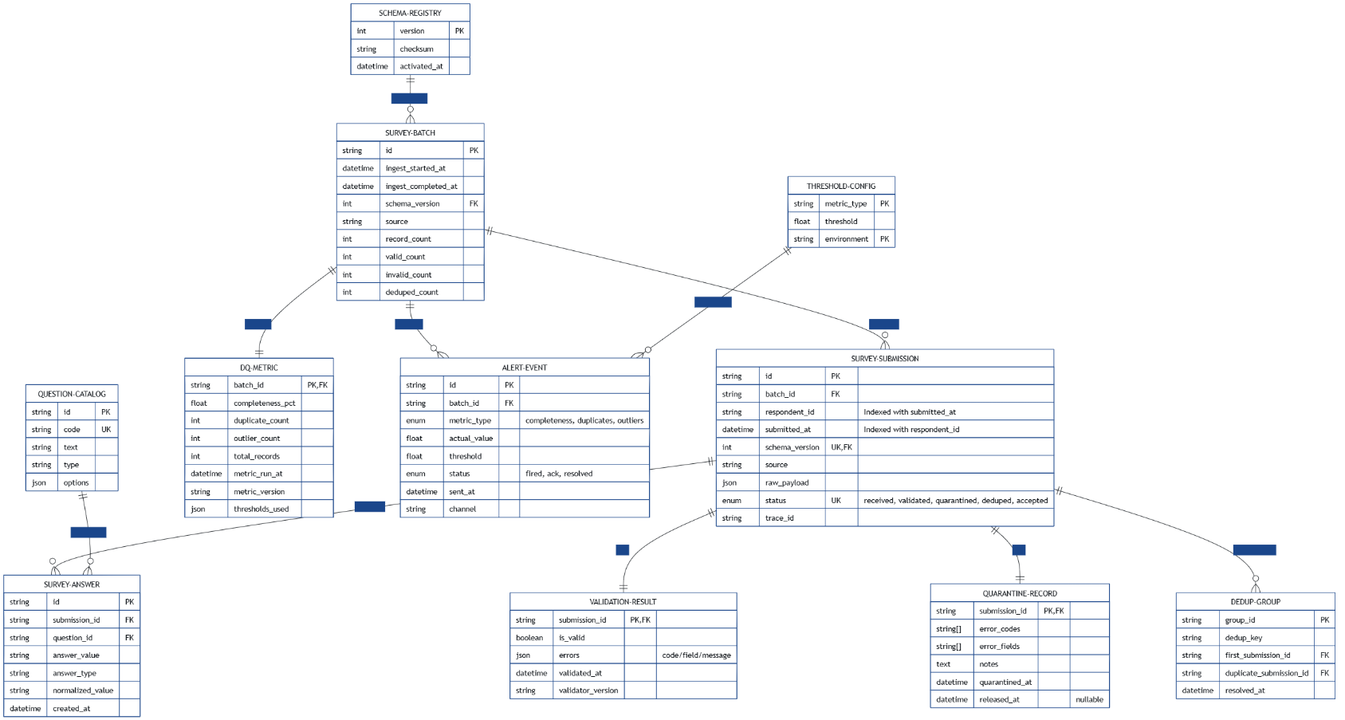
  - Schema Design

- Data Exchange Contract
  - Frequency of data exchanges
- Survey ingestion occurs in near-real time for each submission, with scheduled daily batch processing for legacy and backfilled survey data.
- Data quality metrics are generated after each ingestion batch or on periodic triggers, with alerts evaluated immediately upon metric computation.
- Analytics APIs are accessed on demand, supported by cache-based refresh intervals for frequently requested data.
  - Data Sets
- Survey datasets include raw student responses with schema version, respondent identifiers, and timestamps.

- Validation datasets capture accepted records and quarantined entries with structured error details.

- Data quality datasets store completeness percentages, duplicate counts, and outlier metrics per batch.

- Operational datasets include ingestion logs, alert events, and system performance telemetry.
  - Mode of Exchanges (API, File, Queue etc.,)
- REST APIs (HTTPS) are used for survey ingestion, analytics queries, and dashboard data access.

- Message queues/events are used for validation workflows, data quality computation, and alert triggering.

- Secure file-based transfers (CSV/JSON) are used for bulk survey backfill and batch validation processes.

